- Cut fabric: one main and one lining. Each 8 high x 7.5 wide.

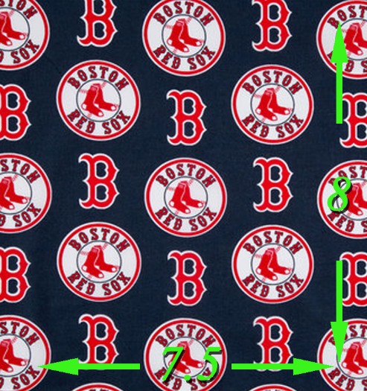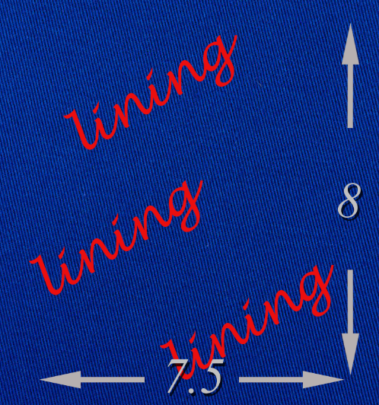

- Cut 2 elastics for over ears. 9” each for adult or 7” each for elemtentary school aged child.

- Each fabric piece: along top and bottom, fold over ¼”. Fold over ¼” again and stitch seam.
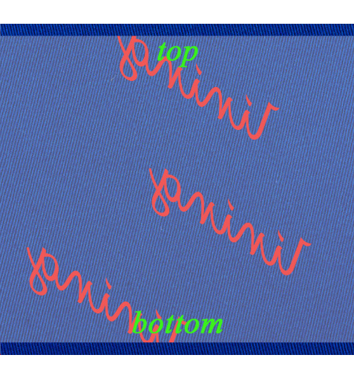

- On the lining piece, on the right side, sew elastics parallel to the top. Approx ¼” to ½” in.
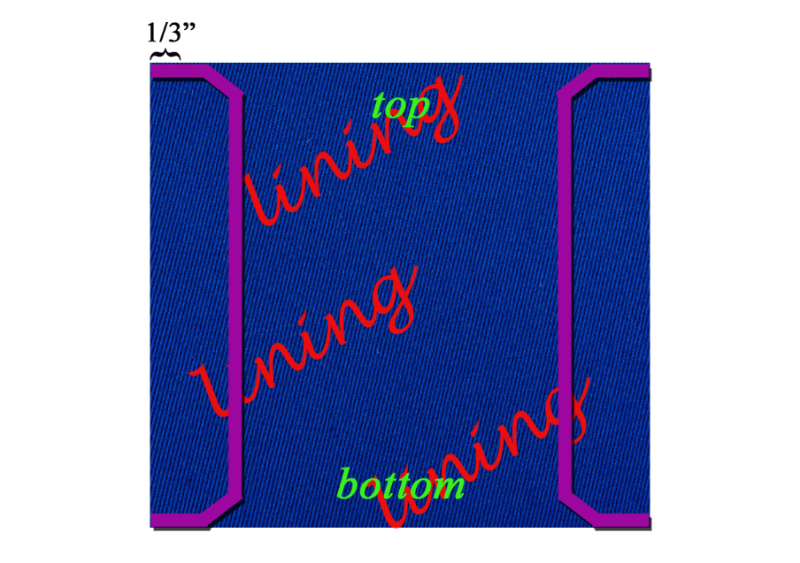
- With the right sides together, keep the elastics in the middle, touching the right sides of the fabric. Stitch the vertical edges that haven’t been stitched. ¼” seam allowance is fine. Basting is fine because you will sew this section again with pleats later.
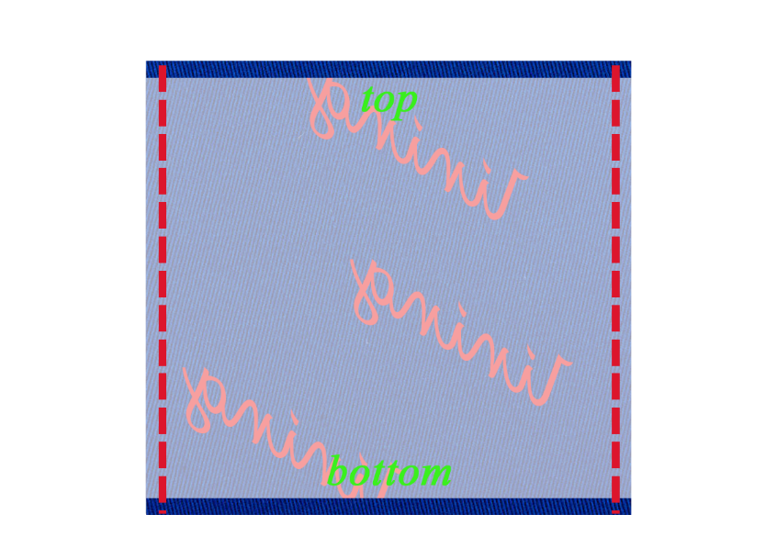

- Stitch the bottom completely and just the top corners 2” on each side, like you do with a purse. You will need a bit of empty room for your hand to turn things right side out again.
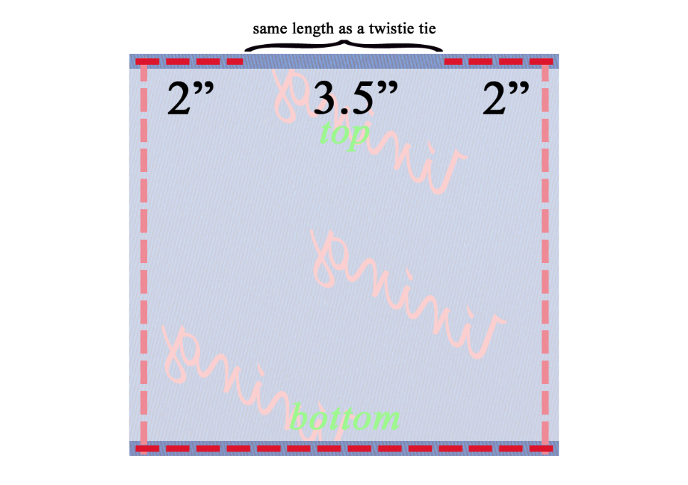
- Turn everything right side out.
- Plan for the folds to open facing downward so they don’t catch debris.
- Use a template that’s narrower than the width to plan the folds and stitch this with the template in along those same vertical edges that you just stitched, but this time with the folds in.

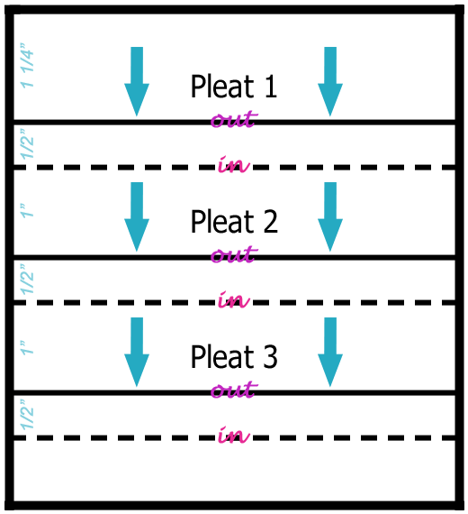

To scale. You can cut this out along the borders and use it.

- Use a twistie tie from the grocery store or pipe cleaner about 2” long.
- Fold in the very edges of the twistie tie by about 1/8” on each side, just to keep them from being sharp and poking through the fabric.
- Finish the mask off by stitching the top and leaving room for the twistie tie. 0.8” to 1” down. You can place a few knots at the top, in the center, once you’ve put the twistie tie in.
